Togaf flow

## Assignment: Find out if you are doing all the activities in the flow

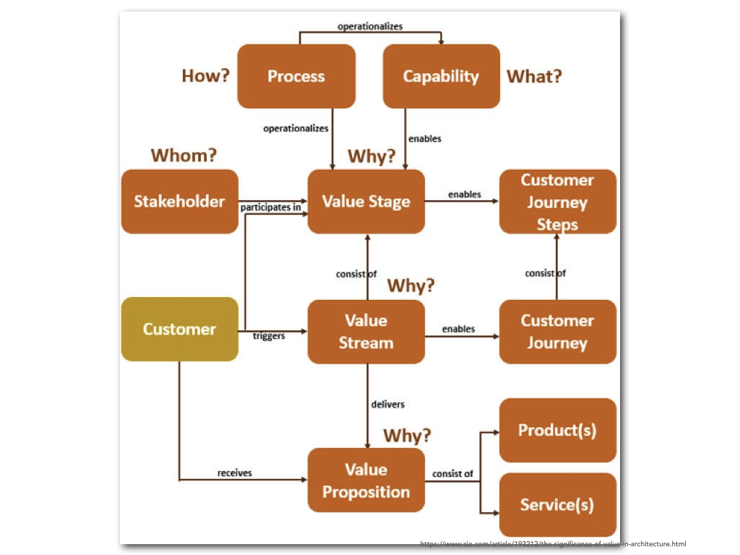

https://www.cio.com/article/193212/the-significance-of-value-in-architecture.html